Uniforms

**PRE-K– 3rd GRADE (GIRLS)**

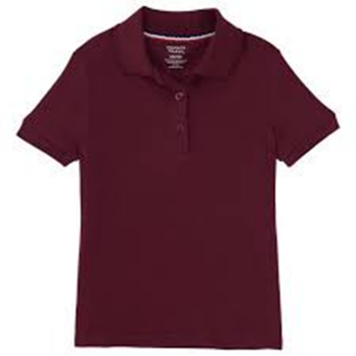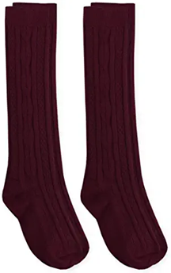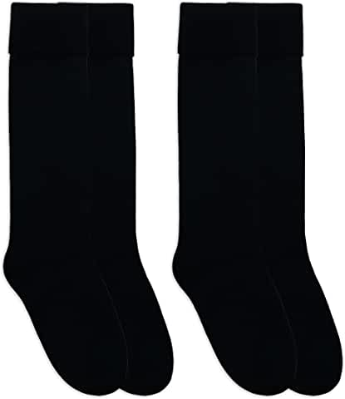

**4TH – 7TH GRADE (GIRLS)**

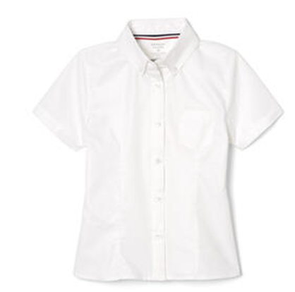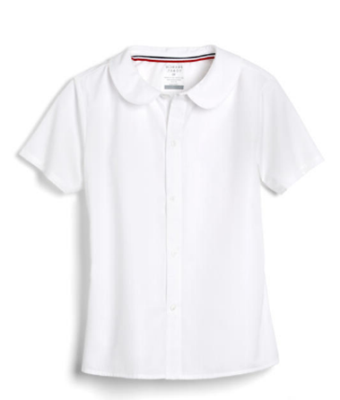

**8th - 12TH GRADE (GIRLS)**

**PRE-K– 12TH GRADE (ALL BOYS)**

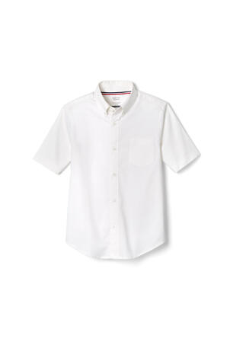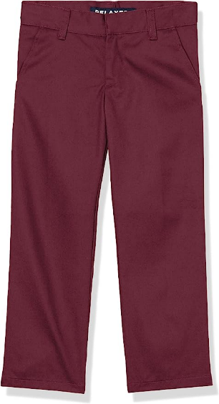

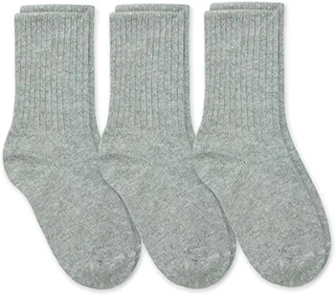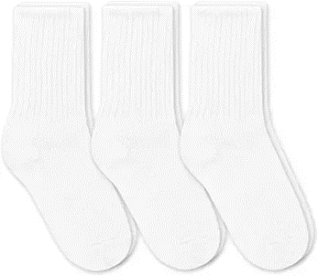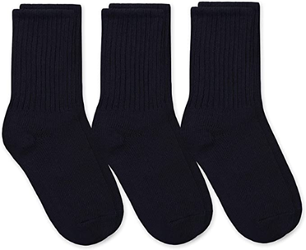

**PRE-K– 12TH GRADE (ALL STUDENTS)**

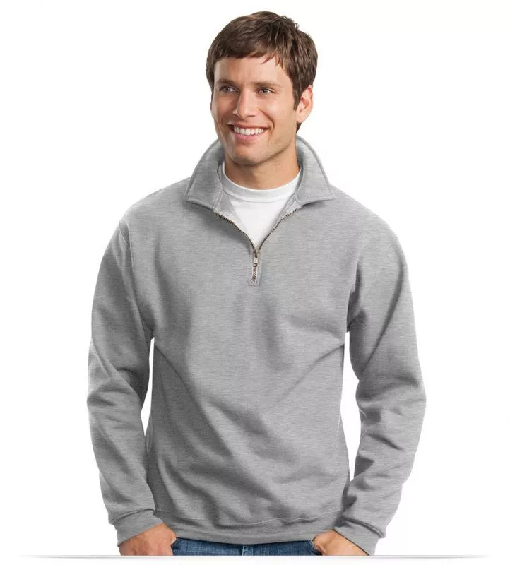

*Uniforms can be purchased from any store.